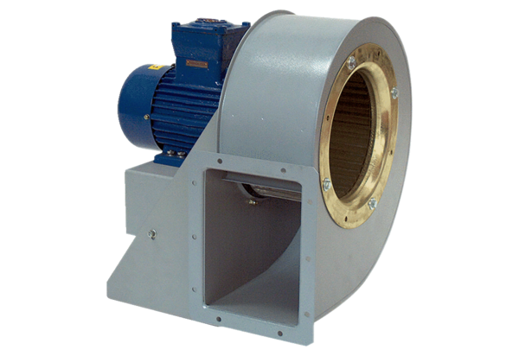Centrifugal blower GRM HD 25/2 ExPacking unit: 1 pieceRange: C
Article number: 0073.0400Manufacturer: MAICO

