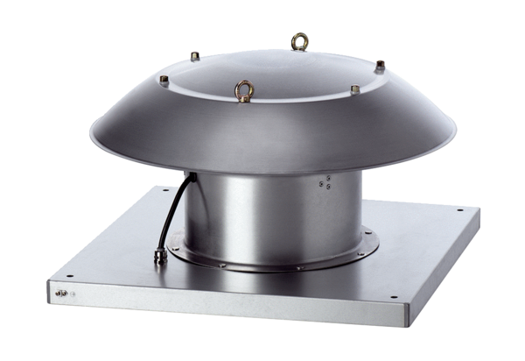Axial roof fan DZD 60/6 B Ex tPacking unit: 1 pieceRange: C
Article number: 0087.0822Manufacturer: MAICO

