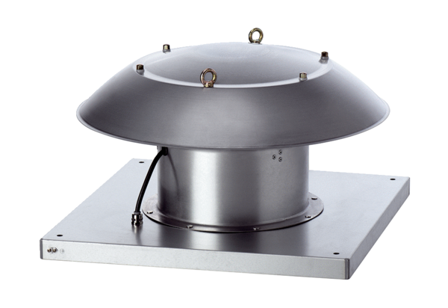Axial roof fan DZD 40/6 B Ex tPacking unit: 1 pieceRange: C
Article number: 0087.0818Manufacturer: MAICO

