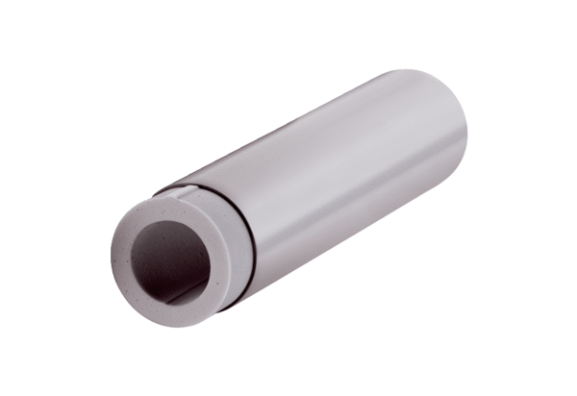Extension kit ALDVS 125Packing unit: 1 pieceRange: B
Article number: 0152.0085Manufacturer: MAICO

