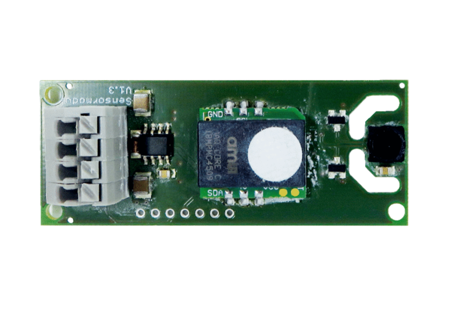Humidity and temperature sensor SE WS 75 HATRange: K
Article number: E157.1609.0000Manufacturer: MAICO

