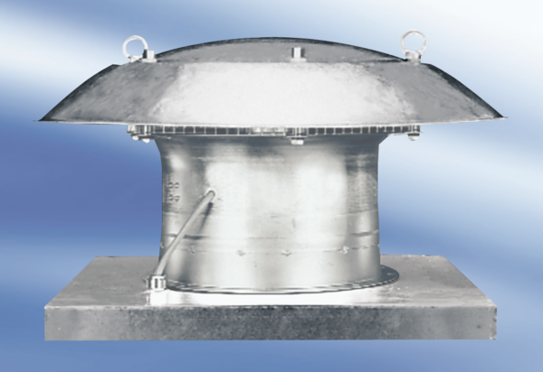Axial roof fan DZD60-4APacking unit: 1 pieceRange:
Article number: 0087.0429Manufacturer: MAICO

