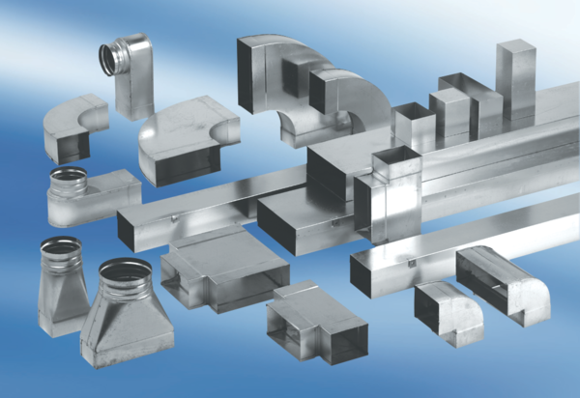Reducer, asymmetrical REDA70/170/55Packing unit: 1 pieceRange: K
Article number: 0055.0712Manufacturer: MAICO

