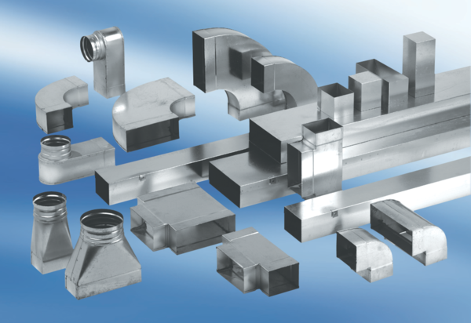Intermediate piece, symmetric USSN55/110/80Packing unit: 1 pieceRange: K
Article number: 0055.0674Manufacturer: MAICO

