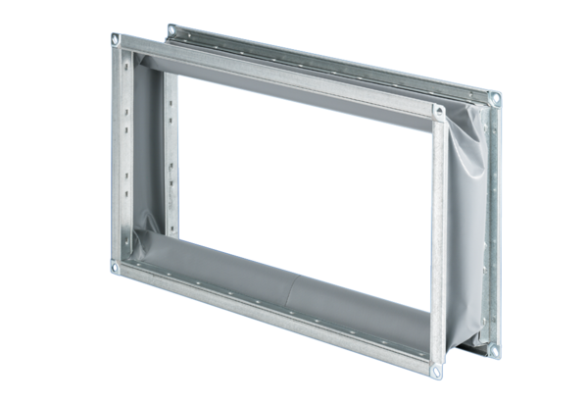Flexible coupling ELP 94Packing unit: 1 pieceRange: D
Article number: 0092.0264Manufacturer: MAICO

