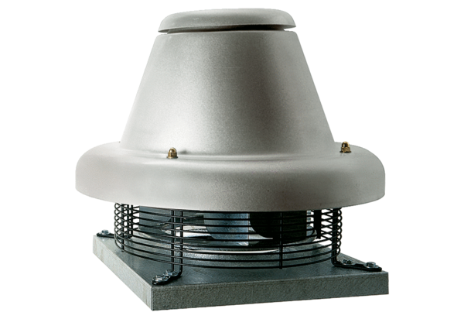Centrifugal roof fan DRD HT 50/6 2VPacking unit: 1 pieceRange: C
Article number: 0073.0023Manufacturer: MAICO

