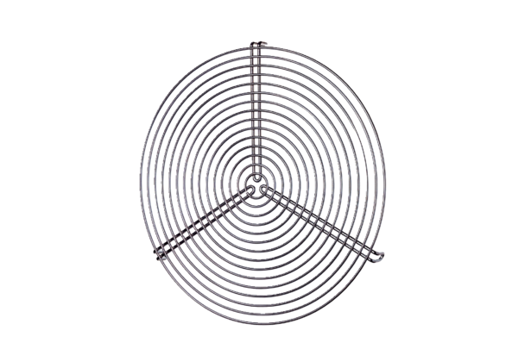Protective grille SGR 12Packing unit: 1 pieceRange: C
Article number: 0150.0124Manufacturer: MAICO

