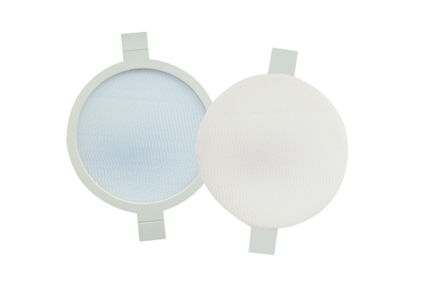Air filter, replacement PPF G3Packing unit: 2 piecesRange: K
Article number: 0093.0169Manufacturer: MAICO

