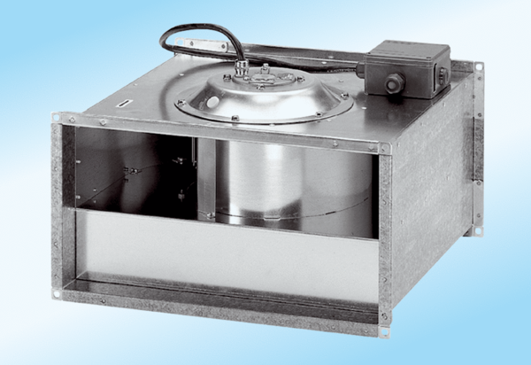Channel fan DPK 28/4 ExPacking unit: 1 pieceRange: D
Article number: 0086.0642Manufacturer: MAICO

