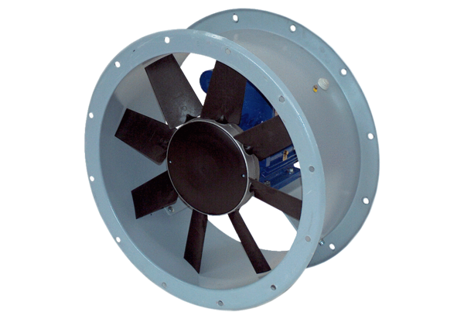Axial duct fan DAR 140/8 5,5Packing unit: 1 pieceRange: C
Article number: 0073.0194Manufacturer: MAICO

