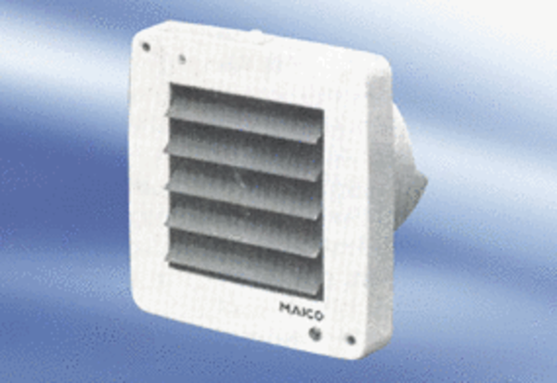Small room fan ECA 9-6 VZPacking unit: 1 pieceRange:
Article number: 080050Manufacturer: MAICO

