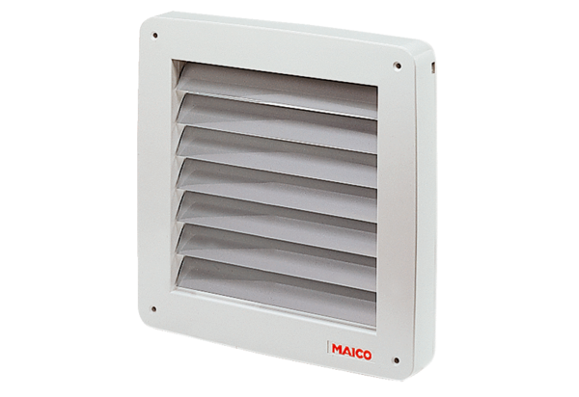Shutter, electric MK 20Packing unit: 1 pieceRange: C
Article number: 0093.0906Manufacturer: MAICO

