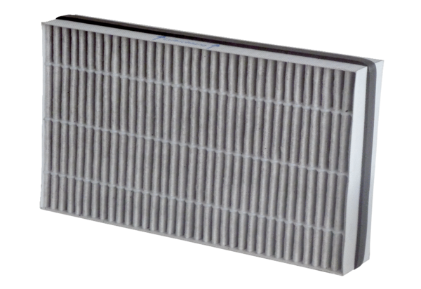Air filter, replacement WSF-AKF 170Packing unit: 1 pieceRange: K
Article number: 0093.0272Manufacturer: MAICO

