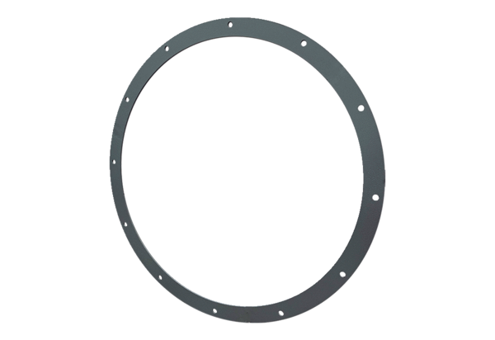Counter flange GFI 63Packing unit: 1 pieceRange: C
Article number: 0073.0259Manufacturer: MAICO

