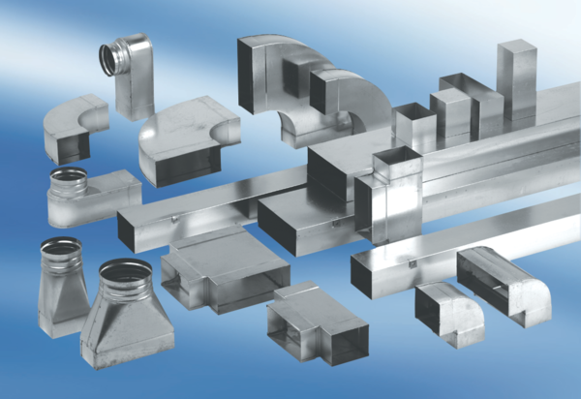Reducer, asymmetrical REDA55/220/55Packing unit: 1 pieceRange: K
Article number: 0055.0707Manufacturer: MAICO

