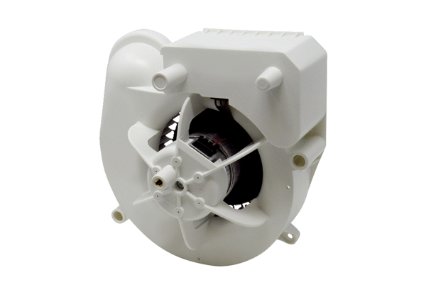Fan insert VE ER-APB 60 VZRange: B
Article number: E084.0157.0000Manufacturer: MAICO

