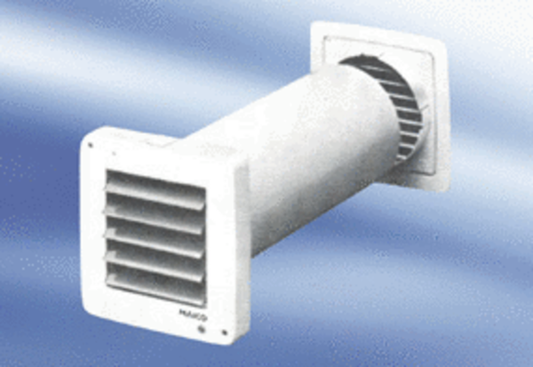Small room fan ECA 9-5 VZPacking unit: 1 pieceRange:
Article number: 080049Manufacturer: MAICO

