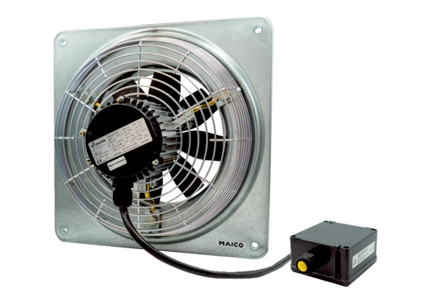Axial wall fan DZQ 45/4 B Ex tPacking unit: 1 pieceRange: C
Article number: 0083.0213Manufacturer: MAICO

