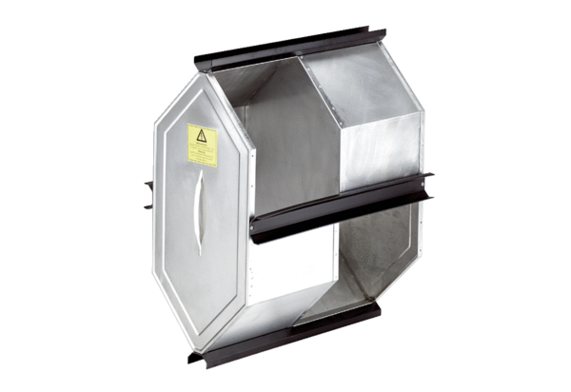Summer cassette SK 300 PlusPacking unit: 1 pieceRange: K
Article number: 0180.0924Manufacturer: MAICO

