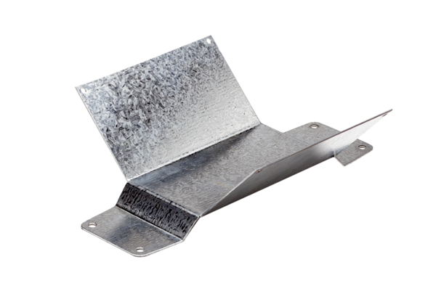Mounting foot FUM 25Packing unit: 1 pieceRange: C
Article number: 0036.0005Manufacturer: MAICO

