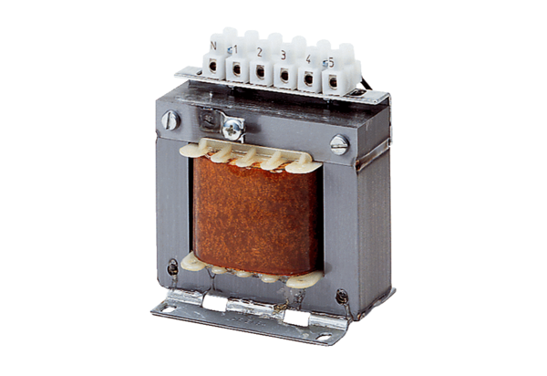5-step transformer, control cabinet TRE 3,3 SPacking unit: 1 pieceRange: C
Article number: 0157.0745Manufacturer: MAICO

