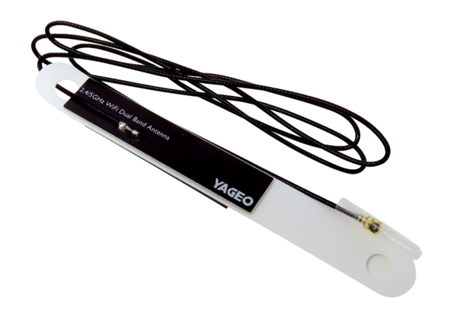WLAN antenna WLANA WS 75Range: K
Article number: E157.1614.0000Manufacturer: MAICO

