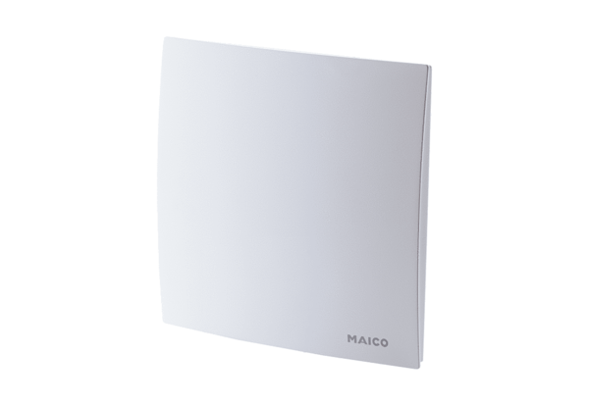Cover ER-AHPacking unit: 1 pieceRange: B
Article number: 0084.0363Manufacturer: MAICO

