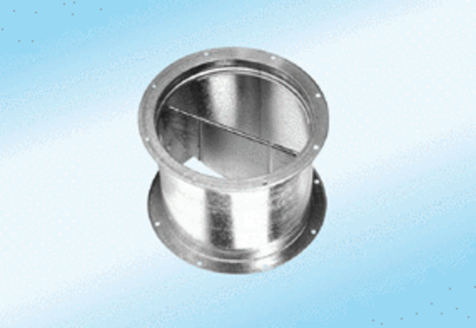Shutter, pull device VD 30-ExPacking unit: 1 pieceRange: C
Article number: 0093.0632Manufacturer: MAICO

