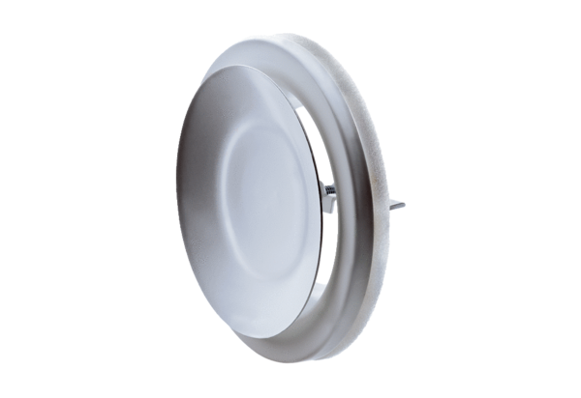Disk valve, metal TFZ 20Packing unit: 1 pieceRange: C
Article number: 0151.0368Manufacturer: MAICO

