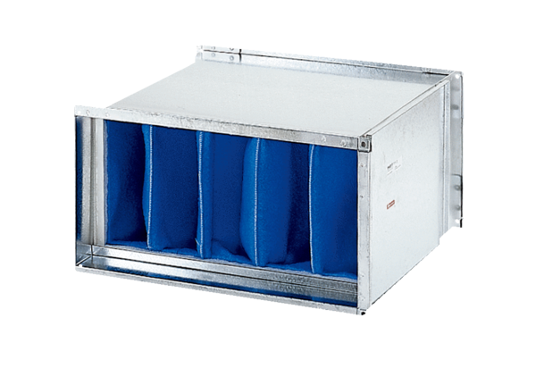Air filter TFP 25Packing unit: 1 pieceRange: D
Article number: 0149.0032Manufacturer: MAICO

