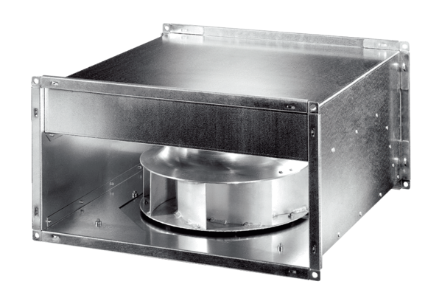Channel fan DPK 31 ECPacking unit: 1 pieceRange: E
Article number: 0086.0802Manufacturer: MAICO

