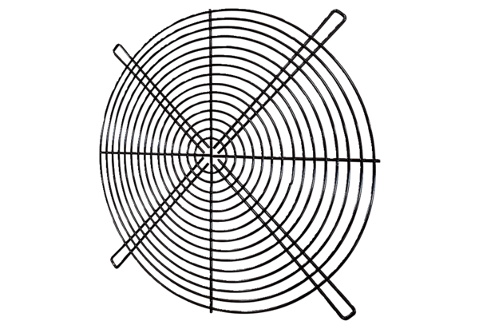Protective grille SGRI 45Packing unit: 1 pieceRange: C
Article number: 0073.0424Manufacturer: MAICO

