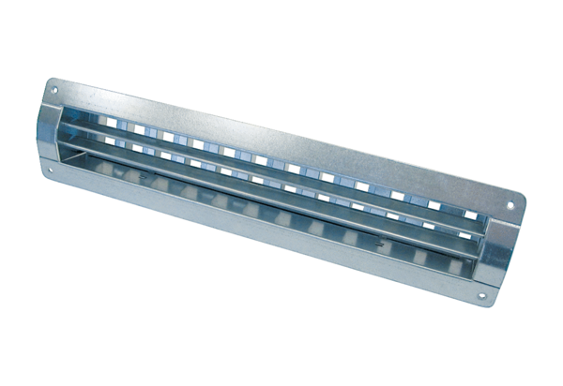Internal grille LGR 82/6Packing unit: 1 pieceRange: C
Article number: 0151.0358Manufacturer: MAICO

