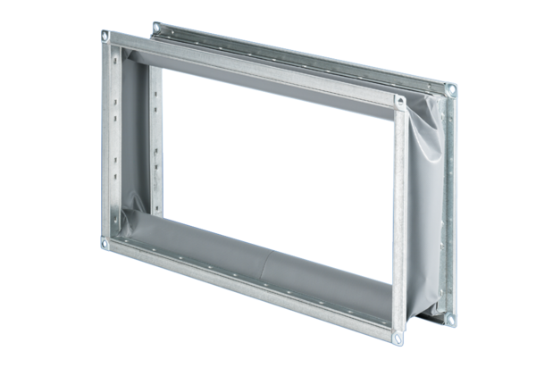Flexible coupling ELP 50Packing unit: 1 pieceRange: D
Article number: 0092.0123Manufacturer: MAICO

