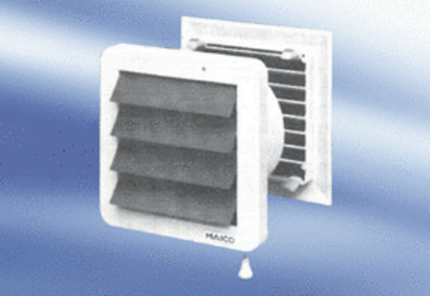Wall-mounted fan EMA 16Packing unit: 1 pieceRange:
Article number: 080274Manufacturer: MAICO

