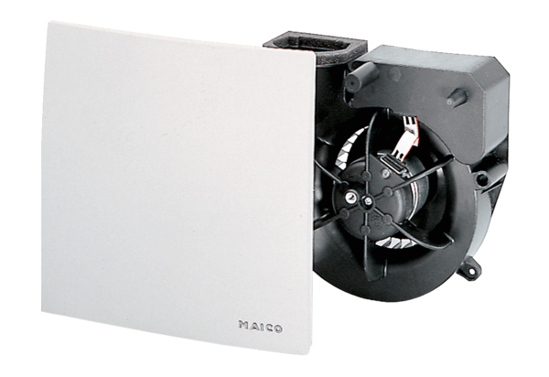Fan insert ER 100 DPacking unit: 1 pieceRange: B
Article number: 0084.0137Manufacturer: MAICO

