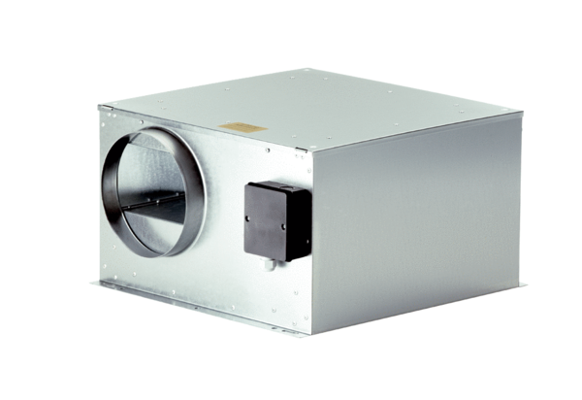Sound-insulated ventilation box ECR-A 16Packing unit: 1 pieceRange: C
Article number: 0080.0566Manufacturer: MAICO

