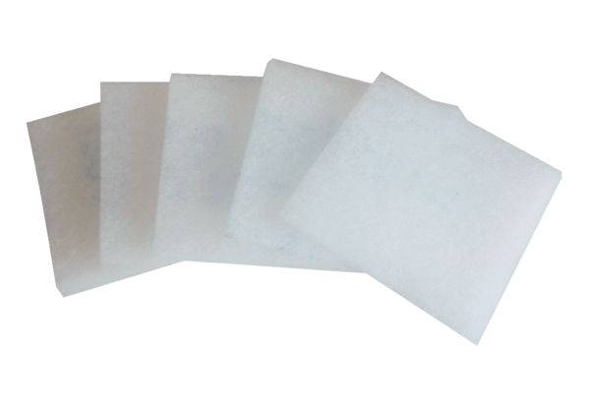Air filter, replacement ZRFPacking unit: 5 piecesRange: B
Article number: 0093.0923Manufacturer: MAICO

