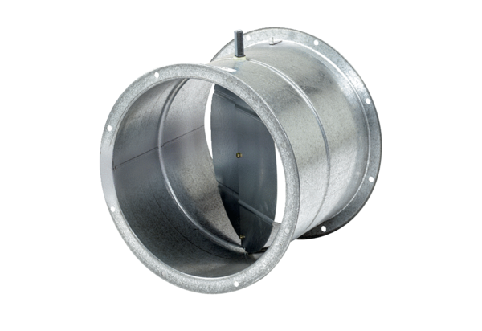Shutter, servomotor VE 60Packing unit: 1 pieceRange: C
Article number: 0093.0290Manufacturer: MAICO

