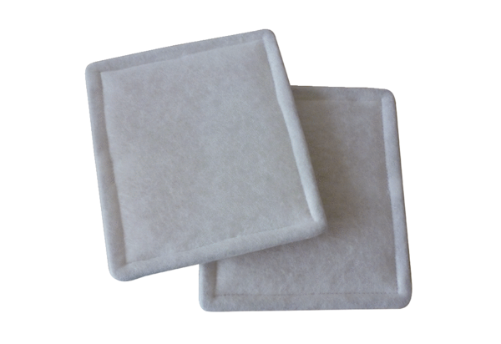Air filter, replacement RF 10-16Packing unit: 2 piecesRange: C
Article number: 0093.0690Manufacturer: MAICO

