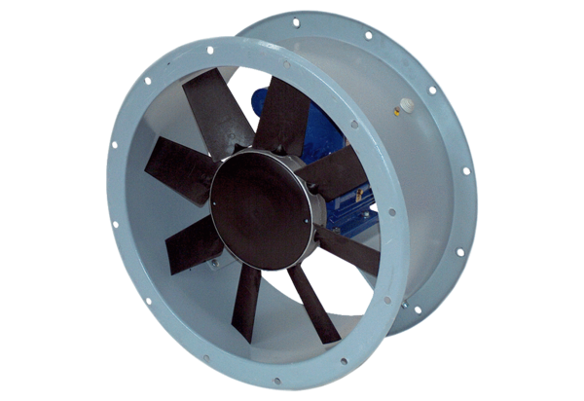Axial duct fan DAR 63/8 ExPacking unit: 1 pieceRange: C
Article number: 0073.0349Manufacturer: MAICO

