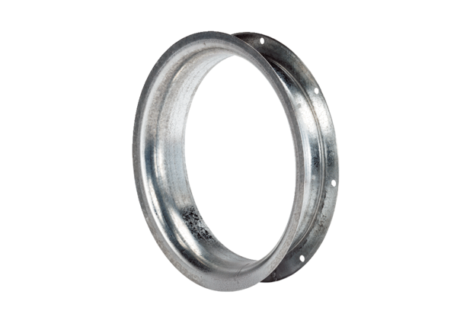Suction nozzle AD 56Packing unit: 1 pieceRange: C
Article number: 0180.0626Manufacturer: MAICO

