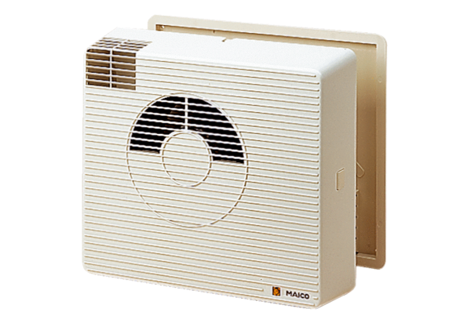Heat recovery unit WRG20-2HPacking unit: 1 pieceRange:
Article number: 0082.0231Manufacturer: MAICO

