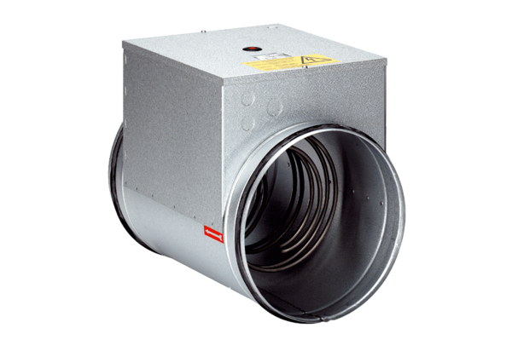Electrical air heater ERH 25-2Packing unit: 1 pieceRange: C
Article number: 0082.0104Manufacturer: MAICO

