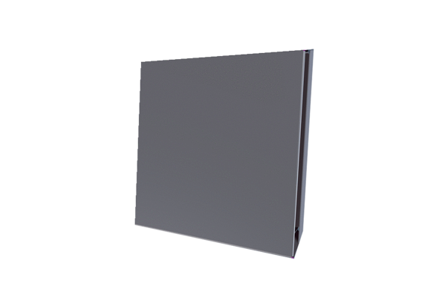External cover PPB 30 AEPacking unit: 1 pieceRange: K
Article number: 0093.1499Manufacturer: MAICO

