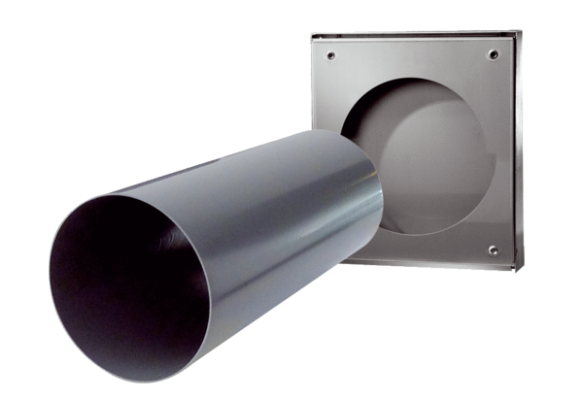Shell kit PP 60 KA-SRLPacking unit: 1 pieceRange: K
Article number: 0095.0216Manufacturer: MAICO

