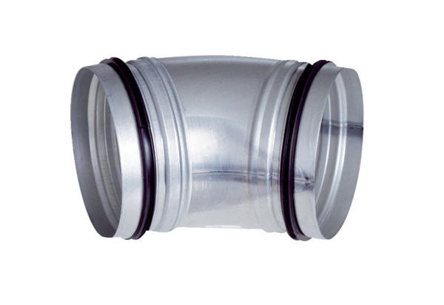45° elbow, drawn B45-125Packing unit: 1 pieceRange: K
Article number: 0055.0326Manufacturer: MAICO

