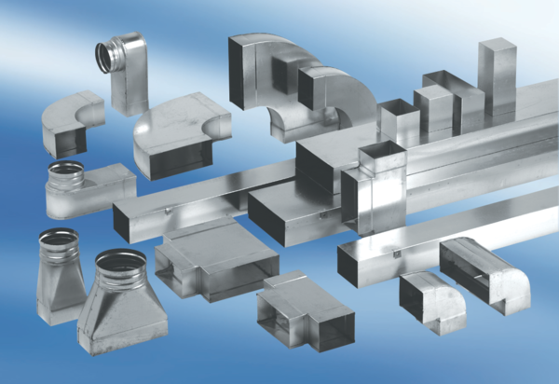Intermediate piece, symmetric USSN55/110/100Packing unit: 1 pieceRange: K
Article number: 0055.0675Manufacturer: MAICO

