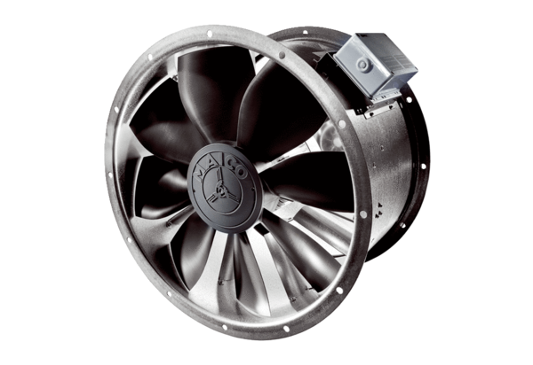Axial duct fan EZL 25/2 BPacking unit: 1 pieceRange: C
Article number: 0086.0070Manufacturer: MAICO

