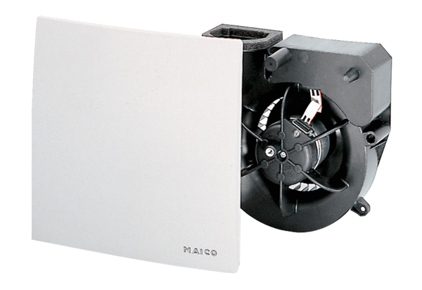Fan insert ER 60 GPacking unit: 1 pieceRange: B
Article number: 0084.0103Manufacturer: MAICO

